|  |
| --- |
| Circle Language Spec: Commands |

## Active Clauses in a Command Definition in a Diagram

This article demonstrates a situation of command objects.

This article illustrates how active clauses in a command definition look in a diagram.

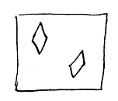

The square is a command definition. The diamond shapes squares inside the square are active clauses inside a command definition. Diamonds inside a square, that do not redirect, are active clauses.